**NASA Information for AI**

# **MARS Launch Vehicle Atlas V-541:**

**Note that the ATLAS V-541 is meant to put rovers on Mars and not Humans.**

## General Information

* It launched the Perseverance Rover in 2020 on a two stage Atlas V-541 provided by United Launch Alliance.

## Launch Facts

|  |  |
| --- | --- |
| **Launched:** | July 30, 2020 4:50 a.m. PDT (7:50 a.m. EDT) |
| **Launch Site:** | Cape Canaveral Air Force Station, Florida |
| **Launch Vehicle:** | Atlas V-541 |
| **Height with payload:** | 191 feet (58 meters) |
| **Mass, fully fueled, with spacecraft on top:** | About 1.17 million pounds (531,000 kilograms) |

* The Mars 2020 mission was designed to launch at a time when Earth and Mars are in positions in their orbits that is advantageous for spacecraft traveling to and landing on Mars. This favorable position of the planets means that it takes less launch energy to get to the Red Planet compared to other times when Earth and Mars are in different positions in their orbits around the sun.

## Different parts of Atlas V-541

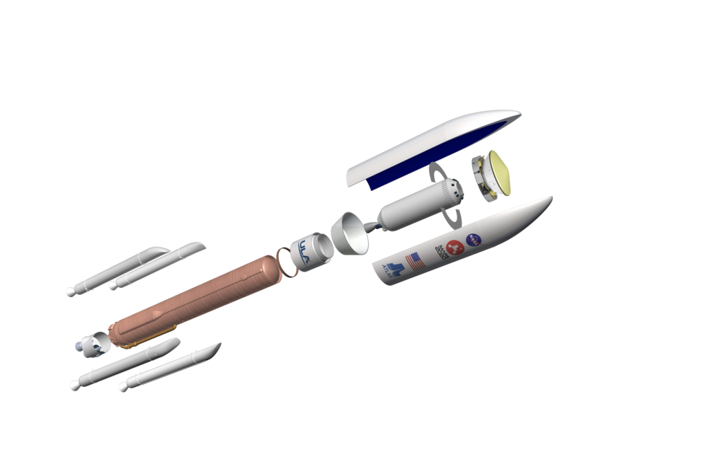

* Stage 1 Atlas V rocket:

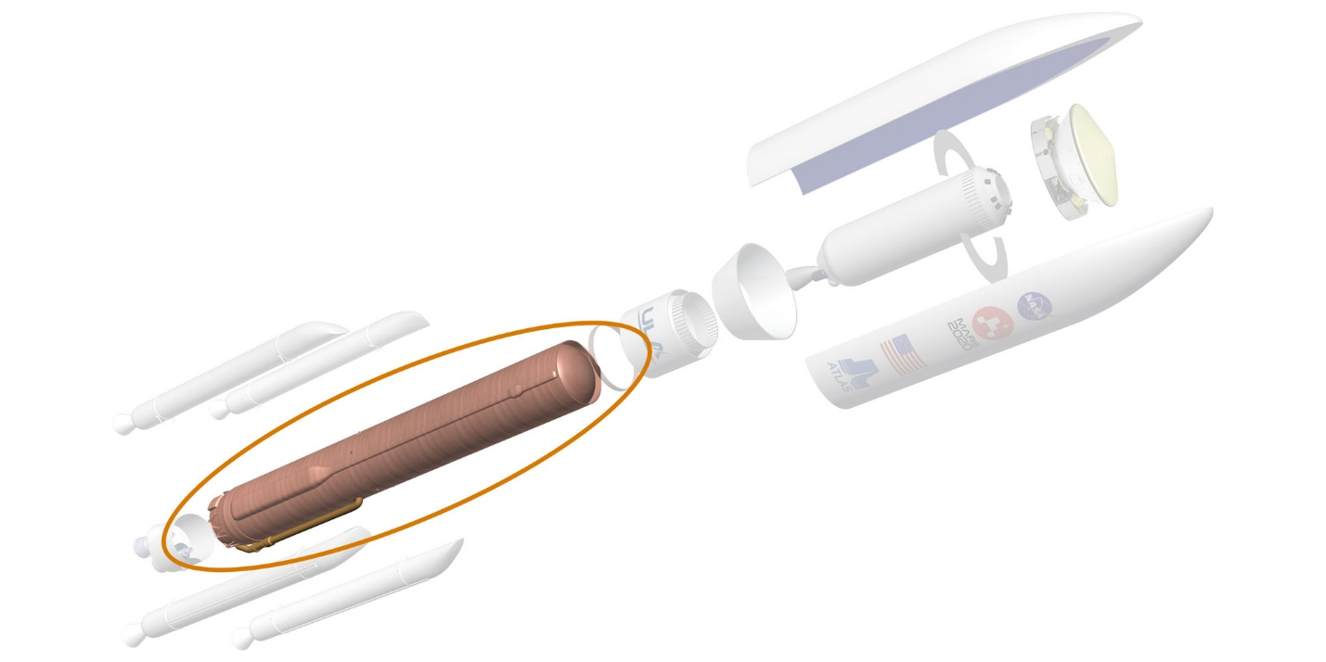

Centerpiece of the first stage is the common core booster, 106.5 feet (32.46 meters) in length and 12.5 feet (3.81 meters) in diameter. It has a throttleable, RD-180 engine from a joint venture. Thermally stable kerosene fuel (type RP-1) and liquid oxygen is loaded shortly before launch into cylindrical fuel tanks that make up about half of the total height of the vehicle. The common core booster can provide thrust of up to about 850,000 pounds (3.8 million newtons) at full throttle.

* Solid Rocket motors:

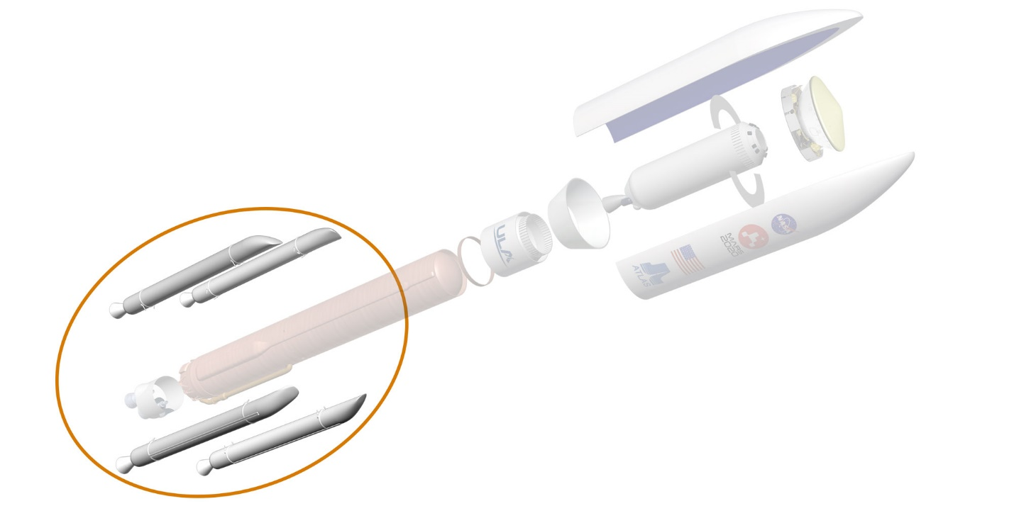

Four solid rocket boosters strapped onto the common core booster add to the thrust produced by the first stage. Each of these boosters is 64 feet (19.5 meters) long and 61 inches (155 centimeters) in diameter, and delivers about 306,000 pounds (1.36 million newtons) of thrust.

* Stage 2 centaur:

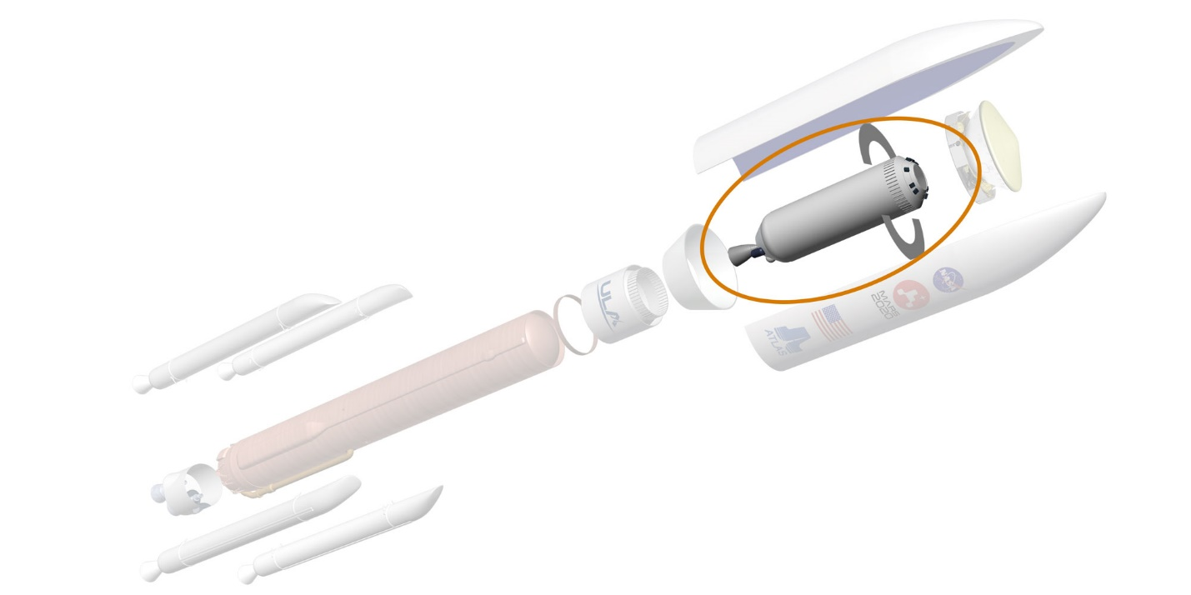

Fuel and oxidizer and the vehicle's "brains"; fires twice, once to insert the vehicle-spacecraft stack into low Earth orbit and then again to accelerate the spacecraft out of Earth orbit and on its way towards Mars.

Two interstage adaptors connect the first stage of the Atlas with its Centaur upper stage. The Centaur's has a restartable RL-10 engine from Pratt & Whitney Rocketdyne. This engine uses liquid hydrogen and liquid oxygen and can provide up to about 22,300 pounds (99,200) of thrust. The Centaur can control its orientation precisely, which is important for managing the direction of thrust while its engine is firing. It carries its own flight control computer and can release its payload with the desired attitude and spin rate.

* Payload firing:

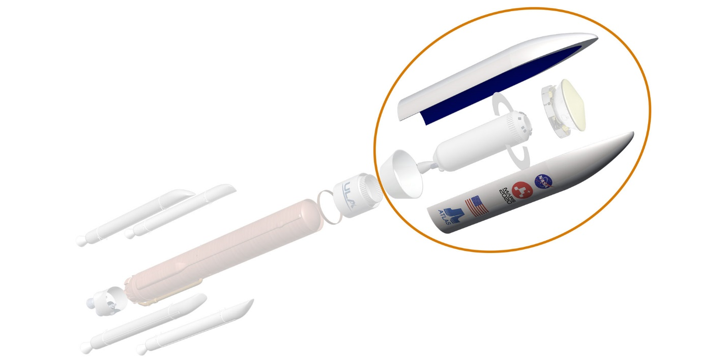

The spacecraft rides into the sky inside a protective payload fairing atop the Centaur stage. With the payload fairing on top, the vehicle stands approximately 191 feet (58 meters) tall when it is ready for launch.

# **Solar System:**

# General Information:

* There are many planetary systems like ours in the universe, with planets orbiting a host star. Our planetary system is named the "solar system" because our Sun is named Sol, after the Latin word for Sun, "solis," and anything related to the Sun we call "solar."
* Our solar system consists of our star, the Sun, and everything bound to it by gravity – the planets Mercury, Venus, Earth, Mars, Jupiter, Saturn, Uranus, and Neptune; dwarf planets such as Pluto; dozens of moons; and millions of asteroids, comets, and meteoroids. Beyond our own solar system, we have discovered thousands of planetary systems orbiting other stars in the Milky Way.
* Our solar system extends much farther than the eight planets that orbit the Sun. The solar system also includes the Kuiper Belt that lies past Neptune's orbit. This is a sparsely occupied ring of icy bodies, almost all smaller than the most popular Kuiper Belt Object – dwarf planet Pluto.
* The order and arrangement of the planets and other bodies in our solar system is due to the way the solar system formed. Nearest to the Sun, only rocky material could withstand the heat when the solar system was young. For this reason, the first four planets – Mercury, Venus, Earth, and Mars – are terrestrial planets. They are all small with solid, rocky surfaces.

## **Different parts of our Solar System**

* The sun:
* The Sun is a yellow dwarf star, a hot ball of glowing gases at the heart of our solar system. Its gravity holds everything from the biggest planets to tiny debris in its orbit.
* Electric currents in the Sun generate a magnetic field that is carried out through the solar system by the solar wind. A stream of electrically charged gas blowing outward from the Sun in all directions.
* The Sun is the largest object in our solar system, comprising 99.8% of the system’s mass. Though it seems huge to us, the Sun isn't as large as other types of stars.
* Earth orbits the Sun from a distance of about 93 million miles. The connection and interactions between the Sun and Earth drive our planet's seasons, ocean currents, weather, climate, radiation belts, and aurorae. Though it is special to us, there are billions of stars like our Sun scattered across the Milky Way galaxy.
* Mercury:
* The smallest planet in our solar system and closest to the Sun. Itis only slightly larger than Earth's Moon. Mercury is the fastest planet, zipping around the Sun every 88 Earth days.
* From the surface of Mercury, the Sun would appear more than three times as large as it does when viewed from Earth, and the sunlight would be as much as seven times brighter.
* Despite its proximity to the Sun, Mercury is not the hottest planet in our solar system – that title belongs to nearby Venus, thanks to its dense atmosphere.
* Because of Mercury's elliptical egg-shaped orbit, and sluggish rotation, the Sun appears to rise briefly, set, and rise again from some parts of the planet's surface. The same thing happens in reverse at sunset.
* Venus:
* Venus spins slowly in the opposite direction from most planets. A thick atmosphere traps heat in a runaway greenhouse effect, making it the hottest planet in our solar system.
* Venus is the second planet from the Sun and is Earth’s closest planetary neighbor. It’s one of the four inner, terrestrial (or rocky) planets, and it’s often called Earth’s twin because it’s similar in size and density. These are not identical twins, however – there are radical differences between the two worlds.
* Venus has a thick, toxic atmosphere filled with carbon dioxide and it’s perpetually shrouded in thick, yellowish clouds of sulfuric acid that trap heat, causing a runaway greenhouse effect.
* Venus has crushing air pressure at its surface – more than 90 times that of Earth – similar to the pressure you'd encounter a mile below the ocean on Earth.
* Earth:
* Our home planet is the only place we know of so far that’s inhabited by living things. It's also the only planet in our solar system with liquid water on the surface.
* While Earth is only the fifth largest planet in the solar system, it is the only world in our solar system with liquid water on the surface. Just slightly larger than nearby Venus, Earth is the biggest of the four planets closest to the Sun, all of which are made of rock and metal.
* The name Earth is at least 1,000 years old. All of the planets, except for Earth, were named after Greek and Roman gods and goddesses. However, the name Earth is a Germanic word, which simply means “the ground.”
* Mars:
* Mars is a dusty, cold, desert world with a very thin atmosphere. There is strong evidence Mars was billions of years ago wetter and warmer, with a thicker atmosphere.
* Mars is also a dynamic planet with seasons, polar ice caps, canyons, extinct volcanoes, and evidence that it was even more active in the past.
* Mars is one of the most explored bodies in our solar system, and it's the only planet where we've sent rovers to roam the alien landscape.
* NASA currently has two rovers (Curiosity and Perseverance), one lander (InSight), and one helicopter (Ingenuity) exploring the surface of Mars.
* Jupiter:
* Jupiter is more than twice as massive than the other planets of our solar system combined. The giant planet's Great Red spot is a centuries-old storm bigger than Earth.
* Fifth in line from the Sun, Jupiter is, by far, the largest planet in the solar system – more than twice as massive as all the other planets combined.
* Jupiter's familiar stripes and swirls are actually cold, windy clouds of ammonia and water, floating in an atmosphere of hydrogen and helium.
* Jupiter’s iconic Great Red Spot is a giant storm bigger than Earth that has raged for hundreds of years.
* Saturn:
* Adorned with a dazzling, complex system of icy rings, Saturn is unique in our solar system. The other giant planets have rings, but none are as spectacular as Saturn's.
* Saturn is the sixth planet from the Sun and the second-largest planet in our solar system.
* Like fellow gas giant Jupiter, Saturn is a massive ball made mostly of hydrogen and helium.
* Uranus:
* The seventh planet from the Sun rotates at a nearly 90-degree angle from the plane of its orbit. This unique tilt makes Uranus appear to spin on its side.
* It was the first planet found with the aid of a telescope, Uranus was discovered in 1781 by astronomer William Herschel, although he originally thought it was either a comet or a star.
* It was two years later that the object was universally accepted as a new planet, in part because of observations by astronomer Johann Elert Bode.
* Neptune:
* The eighth and most distant major planet orbiting our Sun, it is dark, cold and whipped by supersonic winds. It was the first planet located through mathematical calculations, rather than by telescope.
* More than 30 times as far from the Sun as Earth, Neptune is the only planet in our solar system not visible to the naked eye and the first predicted by mathematics before its discovery.
* Pluto:
* Pluto is a complex world of ice mountains and frozen plains. Once considered the ninth planet, Pluto is the largest member of the Kuiper Belt and the best known of a new class of worlds called dwarf planets.
* Pluto, which is smaller than Earth’s Moon, has a heart-shaped glacier that’s the size of Texas and Oklahoma. This fascinating world has blue skies, spinning moons, mountains as high as the Rockies, and it snows, but the snow is red.
* On July 14, 2015, NASA’s New Horizons spacecraft made its historic flight through the Pluto system – providing the first close-up images of Pluto and its moons and collecting other data that has transformed our understanding of these mysterious worlds on the solar system’s outer frontier.

**References:**

* [**https://mars.nasa.gov/mars2020/spacecraft/launch-vehicle/**](https://mars.nasa.gov/mars2020/spacecraft/launch-vehicle/)
* [**https://solarsystem.nasa.gov/solar-system/our-solar-system/overview/**](https://solarsystem.nasa.gov/solar-system/our-solar-system/overview/)